APPENDIX C

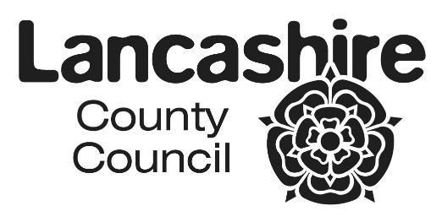

Our approach to casework is detailed in our service offer and specification. Our support for children, young people and family's model is underpinned by a robust assessment (CAF) and is delivered through a range of Centres, in family homes and in community venues.

Family Support work is targeted to reach families at Level 2 on the Lancashire Continuum of Need, and is based on a programme of interventions, identified in a SMART plan, over a 12 week period.

All families who receive this support will have a named Lead Professional and this work follows the principles of one family, one worker and one plan.

The service offer determines the level of group provision within each of our Centres.

We will deploy a variety of group based interventions to support parents, families, children and young people which target specific areas of need or vulnerabilities at an early stage.  Group based interventions may also be used as support to assist in de-escalation from or work alongside Family Support interventions.

Group based interventions will respond to local need across the Local Authority District areas.  Some group work will be effective in discharging our statutory universal responsibilities

Wellbeing, Prevention & Early Help Service

**Methodology**

Outreach and Detached work is a methodology used in both one to one and group work by WPEHS. Workers will use a centre as their base of operations whilst their delivery to children, young people and their families will be remote from the centre into deprived neighbourhoods/outlying areas/rural communities/anti-social behaviour hotspots etc., This work is designed to provide a contained programme of work into communities not easily served by the geographical placement of a Centre and may include use of WPEHS vehicles or be based in 'other partner's venues'. There will be proportionate use of outreach work as defined by the needs of children/young people/families, to enable suitable access to services and facilitating excellent reach.